Background on Human Resources Database Table

# Table Description and Usage

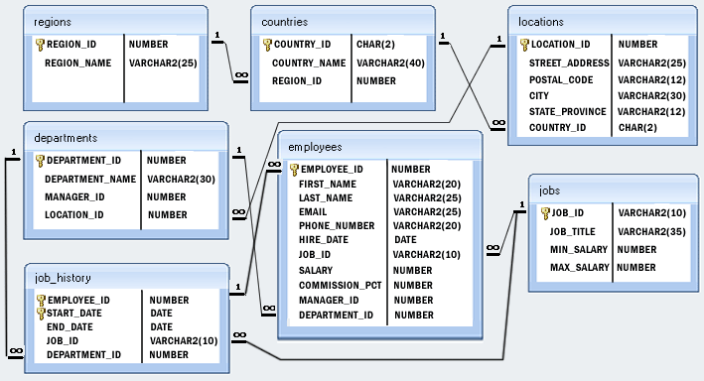

The database supports the storing of employee personal information and other business-critical records such as recruitment, job history, office location and benefit records.

The ‘*employees’* table is the hub of the database. Each record represents an employee at the company. By extension, the ‘*department’* table carries additional information that goes beyond just the department ID, including the name of the department, the manager of that department and where it is based. The ‘*job_history’* table provides further specific recruitment-related information of an employee, such as his/her start and end date. Linking with it is also the ‘*jobs’* table where further information about the employee’s job is provided to include the job title and the salary range.

The ‘*locations’*, ‘*regions’* and ‘*countries’* tables allow us to drill down further into the geographic situation of an employee’s department.

# Table Listings

1. **Employees**

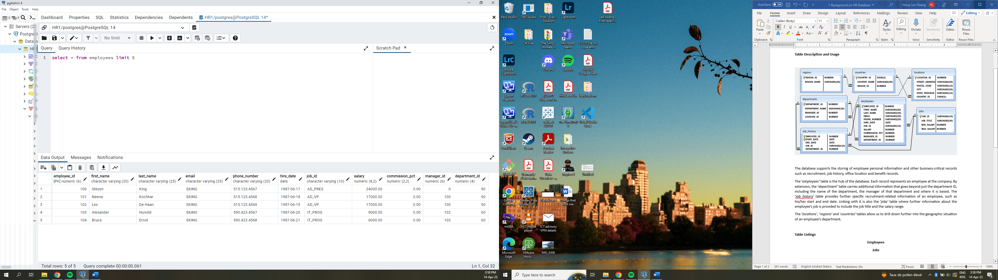

1. **Jobs**

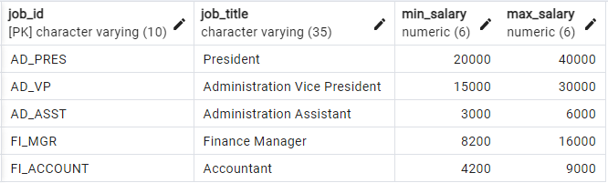

1. **Job_history**

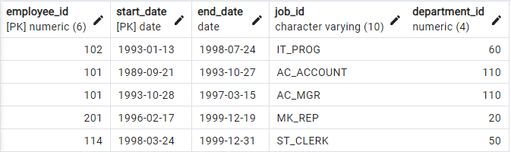

1. **Departments**

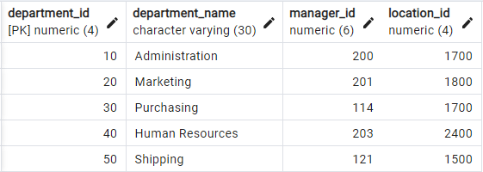

1. **Locations**

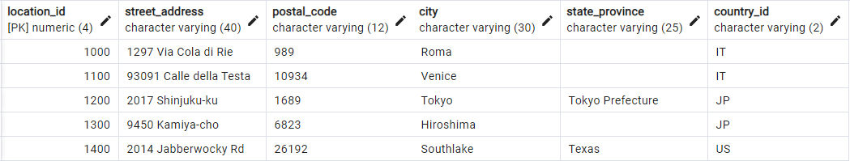

1. **Countries**

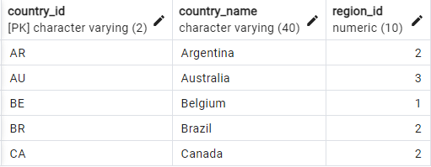

1. **Regions**

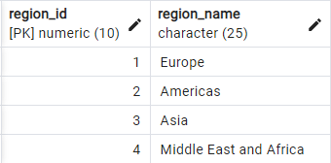

# Primary and Foreign Keys

The primary and foreign keys are also depicted in the figure above. Understandably, an employee is related to one department, one job and one job history in the company. But a region could be related to multiple countries, and a country could be related to multiple department locations. A location could have multiple departments, but a department is specific to a location.

All foreign key columns are required, the user thus must enter a valid value according to the specified integrity rules (including referential integrity). For example, when inserting a new row in the *employees* table, the user must know the employee ID.